How to setup remote web management for F9
Model Number: F9 Question Classification: Remote web management
Remote WEB management is to manage access to routers in the extranet (other networks).
The computer can be connected to the router through the network, if the notebook also can be connected to the router through the wireless, as follows:
Wired connection:
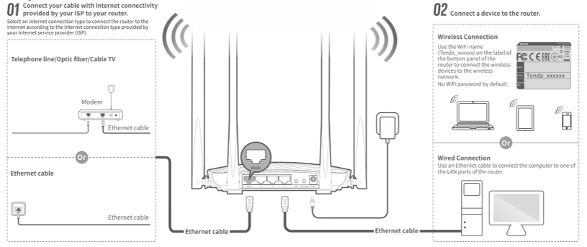
Wireless connection:
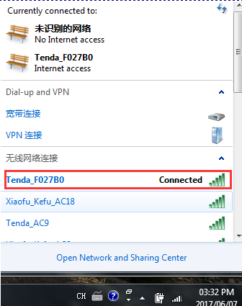
Open the browser, enter "tendawifi.com" or "192.168.0.1" log in to the router settings page in the address bar. (the factory without login password)
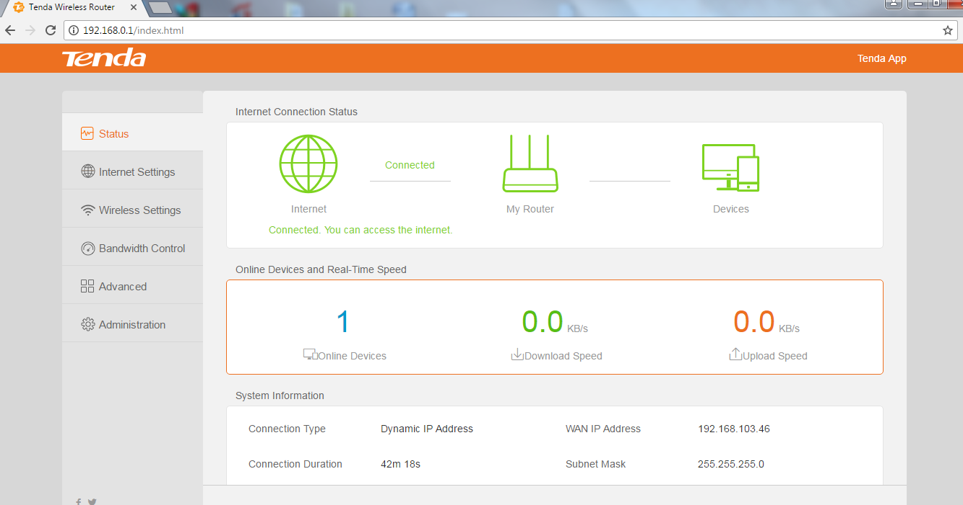
- Open ”System”:
Remote Web-based Management : click “Enable”;
Management IP Address : select “All”;
Port: use the default port number "8080" or modify the other port number;
Click “OK” (port range 1-65535)
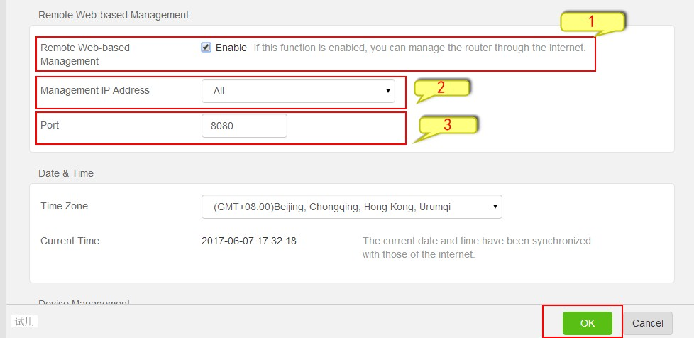
- After the installation is successful, the access method: device access from the extranet (other network) is accessed through the IP and port numbers of the router's WAN port

Note: Set the Remote web management condition is that WAN port IP of the router is to obtain public IP, judgment method : At the Baidu search bar you should enter "IP" and click "use Baidu Search" to check whether the IP address is same with the WAN port of the router address, if yes, you can use the Remote web management function.

